### DCGM – c/o ÄZQ, TiergartenTower, Straße des 17. Juni 106-108, 10623 Berlin

To

Professor Li Xun

President of First Hospital of Lanzhou University

Lanzhou, Gansu

P.R. China

By email

February 2021

Dear President Professor Li Xun,

Chinese New Year-Festival is the most important festivity for the families and of great importance for the entire Chinese society.

I am happy to congratulate with my deep wishes for health and continuous success for you and your family. Please forward my greetings to all my friends of your staff at First Hospital of Lanzhou University and to all supporters of our cooperation.

In the recent year you and all your staff at FHLU worked so hard to overcome any obstacles on your way to a very successful and highly ranked academic health care center within the University Hospitals in China. I am proud to be a humble partner of your institution.

I would like to thank all who helped to fulfill the contract of Lanzhou University and First Hospital of Lanzhou University with me in the past. Everything for the first year of cooperation, for 2019 has been completely settled to my satisfaction. Now I am looking forward to a new phase of collaboration. I am fully supporting your plans, not only for the Trauma Center, but for all your ideas to strengthen the position of FHLU in Gansu Province as the leading institution in many fields in medicine. With help from Regensburg University and Regensburg University Hospital and great support by the German-Chinese Society for Medicine we can reach for new horizons.

I now send all the best wishes for Chinese New Year to you, also to your families and of course the great scientific societies you guided and guide and will influence over lifetime.

I hope you can celebrate Chinese New Year at home and have a reunion dinner with your family with traditional Chinese New Year food. Enjoy all the delicacies of great Chinese food with your loved ones!

This year is the Year of the Ox, which symbolises strength and determination – handy, because we could all do with a lot of that right now.

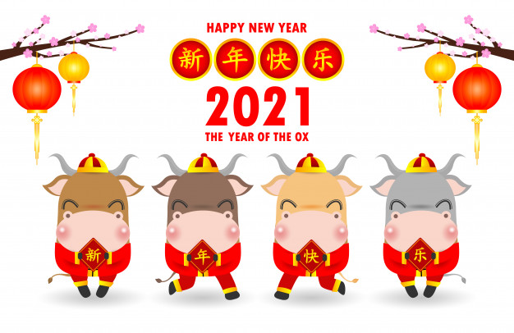



|  |
| --- |
| Prof. Dr. Michael Nerlich  President of German-Chinese Society of Medicine |
|  |